Land use - Year 2016
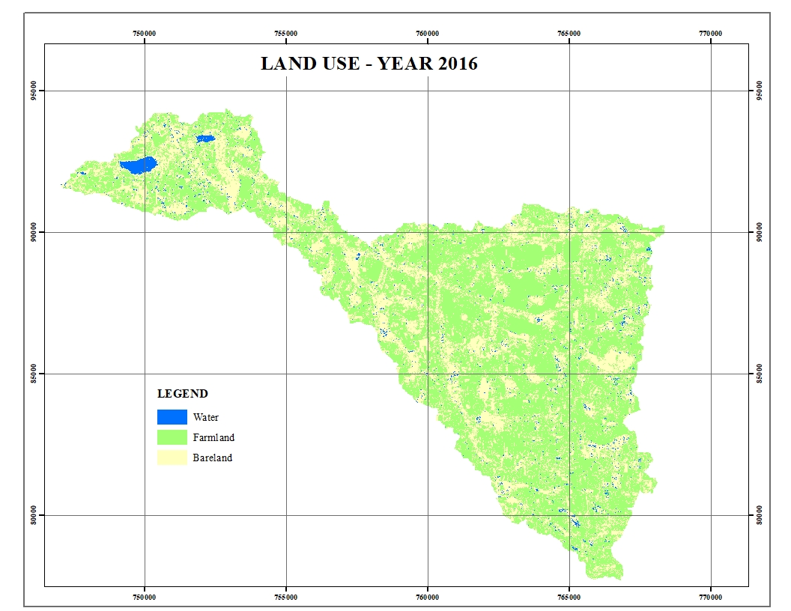

Land use - Year 2020

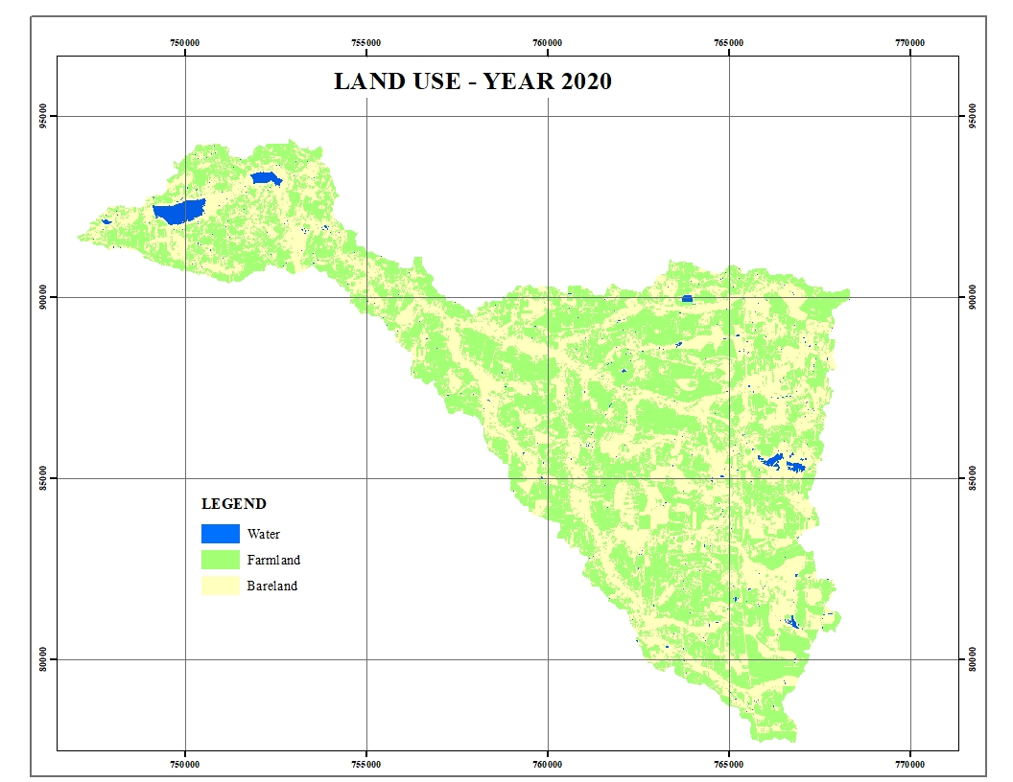

Land use year 2024
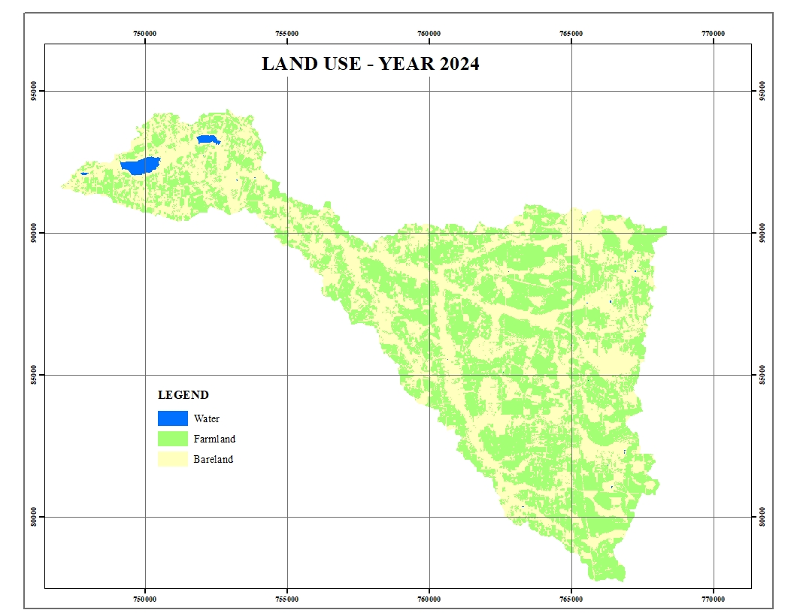

Area (Ha)
 | 2016 | 2020 | 2024
Farmland | 7451.83 | 6190.70 | 5958.03
Bare land | 4024.06 | 5337.55 | 5645.09
Water | 209.81 | 153.90 | 82.87

